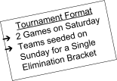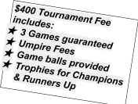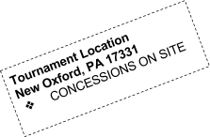
Landshark 8U/ 9U Memorial Baseball Tournament Registration
Team Name: _____________________________________________
Division: 8U or 9U
Coaches Name: ___________________________________________
Address: ________________________________________________ City: _____________________________________Zip: ___________
Phone: _________________________________________________
email: __________________________________________________
Make Checks payable and mail to: South Central PA Landsharks
℅ Matt Baker
872 Poplar Road
New Oxford, PA 17350

